
PUCIT
Punjab University College of Information Technology

FCIT Degree Clearance System

.

Table of Contents

1.1 Project Title 3
1.2 Project Overview Statement 3
1.3 Project Goals & Objectives 4
1.4 High-level system components 4
1.5 List of optional functional units 4
1.6 Application Architecture 5
1.7 Gantt chart 5
1.8 Hardware and Software Specification 6
1.9 Tools and technologies used with reasoning 6

1.1 Project Title

FCIT Degree Clearance System

Project Overview Statement.

Project Title: FCIT Degree Clearance System

Group Leader: Abu Huraira

Project Members:

Name | Registration # | Email Address | Signature
Ikram Anwar | BSEF19A512 | bsef19a512@pucit.edu.pk
Ahmar Farooq | BSEF19A528 | bsef19a528@pucit.edu.pk
Muhammad Abdullah | BSEF19A529 | bsef19a529@pucit.edu.pk
M. Subhan Ansari | BSEF19A535 | bsef19a535@pucit.edu.pk
Abu Huraira | BSEF19A545 | bsef19a545@pucit.edu.pk

Project Goal: The goal is to automate the Degree Clearance Process by developing a software.

Objectives:
Sr.#
1 | To provide an effective and reliable solution to degree clearance process.
2 | To fulfills the flaw of existing manual system. Like queuing, waiting, losing of documents.
3 | To save a lot of time and efforts
4 | To help the university reducing the cost of faculty and stationery.
5 | To eliminate queuing and traveling of students.
6

Project Success Criteria: Our project will meet the success criteria if it effectively manages the degree clearance process of graduates by collaborating with students and faculty.

Assumptions, Risks and Obstacles: Secure System

Organization Address (if any): FCIT

Type of project: Web Development

Target End users: FCIT Students and Faculty

Development Technology: Object Oriented

Platform: Web based

Suggested Project Supervisor:

Approved By:

Date:

1.3 Project Goals & Objectives
The objective of this process is to develop a degree clearance system. This will be computerized and can be accessed online. This software will make the student enable to do their clearance online instead of visiting different departments and offices.

1.4 High-level system components
These are the high-level components of the system.

- Login
- Putting an application for clearance purpose.
- View application status
- Approving applications
- Generating approval document
- Generating Transcript
- Notify by mail

.

1.5 List of optional functional units

- Forget Password scenario
- Backup Data

1.6 Application Architecture

.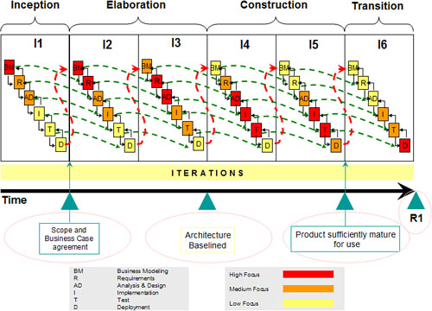

1.7 Gantt chart

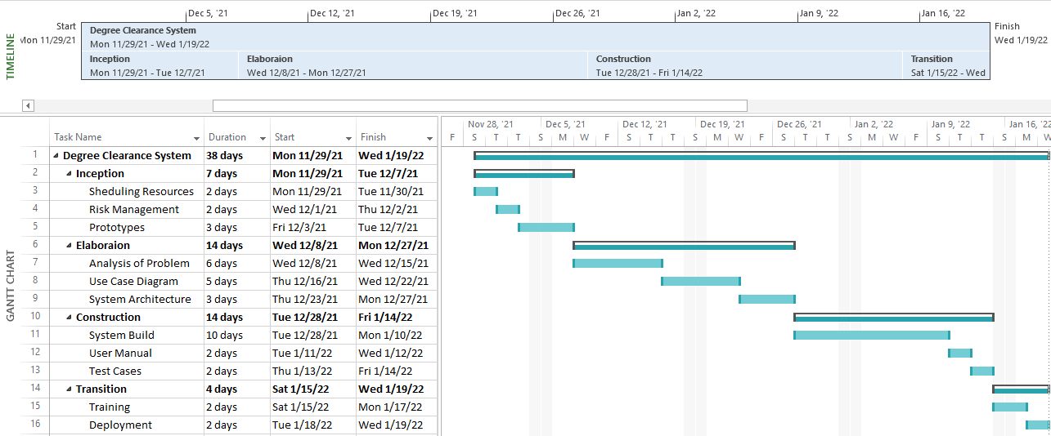

1.8 Hardware and Software Specification

- Intel Core™2 Duo Processor or higher
- RAM 512 or higher
- All operating systems having web browsers

1.9 Tools and Technologies

Development Process:
We will follow iterative development process

Programming Languages:

- React
For front end purpose, React will be used.
- Tailwind
For Styling purposes of website, Tailwind will be used.
- Express
For Server and back end purposes, Express will be used.

Tools:

- Adobe Photoshop
We will use adobe photoshop for designing the layouts of our web pages.

- VS Code
For writing code of Web page front end and to handle backend business logic of system as well as managing data by collaborating with database. VS code will be used.

- Node Js
We will use Node Js for creatin express server and react codes.

- Rational Rose
For all types of UML diagrams and visual modeling for conceptual representation of our system, we will use Rational Rose as our tool.

- MS Word
MS Word will be used for proper documentation as well as making an elegant user manual of the Software System.

- MongoDB
This MongoDB will be used as a database for storing data of students, faculty, and applications of other business rules.

